TAS Library Rules:
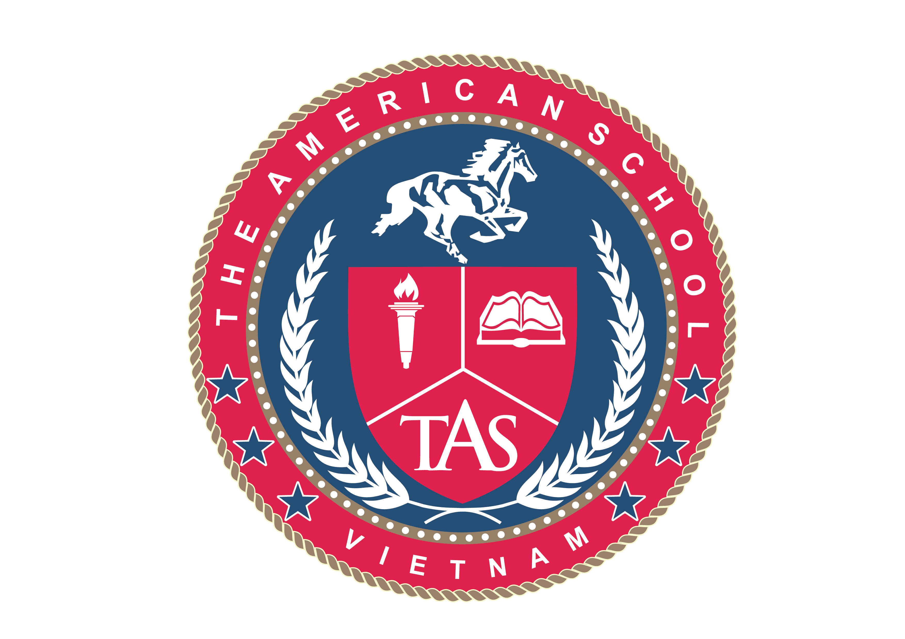
- Noise, disturbance or inappropriate behavior is prohibited, including abusive or threatening behavior to Library staff and other Library users.

- No food is permitted in the Library buildings. Soft drinks and hot drinks may be consumed in the Library as long as they are in non-spill containers, cartons, cans or bottles. Anyone found to be eating in the Library will be asked to dispose of the food or take it outside. Food left unattended will also be removed.

- All devices in the library must be set to silent mode.

- No material other than official notices from the Library or the School may be distributed or posted within the Library, without the permission of the appropriate Library manager.

- Library furniture, fittings or equipment must not be misused or their arrangement altered. After a beanbags and chairs are used, they must be put back in their place.

- Library users should not attempt to reserve study spaces by leaving personal belongings at desks when they have left the building. Belongings may be cleared to allow others to use study places. Note that any unattended belongings are left at the owner's risk and users are strongly advised not to leave valuables even if they will be away from the desk for a short time.

- Study space and group study room bookings take precedent over casual use of space and rooms. A user who has booked a study space or room can expect any other user occupying it, at the reserve time, to vacate it.

- Any damage or defacement of Library materials is strictly prohibited and users found damaging material will be subject to disciplinary procedures. Library users are asked to report any instances of such defacement to Library staff.

- Use of information technology facilities within the Library is governed by library administrators, every student should ask a librarian before using the IT facilities.

- Booked study groups or classes must always remain with a teacher or an assistant.

- If you don’t remember where a book belonged on a shelf, ask a librarian.

- Library computers are meant to be used for academic purposes. For social media, games and recreational purposes, personal devices are permitted AFTERSCHOOL as long as they are used responsibly.

- All students in the library during class periods must be supervised by a teacher or a library pass signed by a teacher.

TAS Library CHECK OUT Rules:
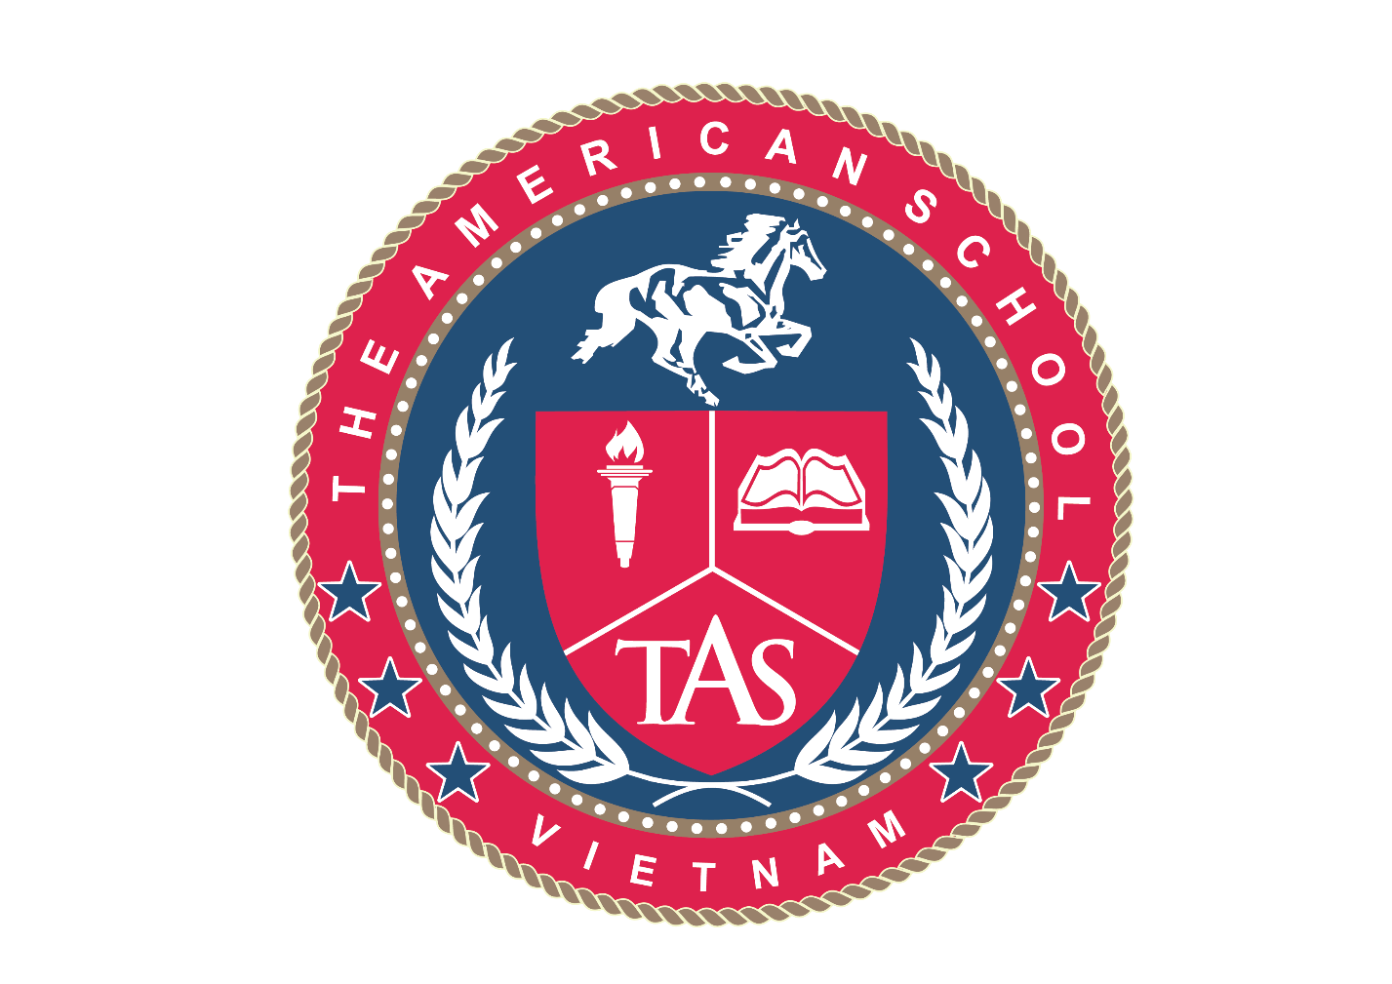
MSHS library materials

- Students will be allowed to check out up to 3 books at a time. The normal check out time is 2 weeks, but students may ask for renewal.
- In case of overdue materials, students will lose to the privilege check out a new material for a period.
- Repeated cases of overdue materials will result in temporary suspension of the account.
- Special cases will be considered depending on the library record.
- Textbooks and class materials will have a special circulation time and rule, and will not count into the 3 books limit.
- Students are responsible for their checked out textbook. Each textbook has a barcode that identifies it. Upon return, a student must return his or her checked out textbook and no other.
- Students are not allowed to check out class set books unless a teacher has requested so.
- Summer holiday check outs will be permitted only under teacher request.

Elementary library materials

- Students will be allowed to check out depending on their grade. The normal check out time is 1 week, but students may ask for renewal.
- G1 will be allowed to check out 1 book per week
- G2 will be allowed to check out 2 books per week
- G3 and G5 will be allowed to check out 2 books per week as well.
- G3 to G5 will be allowed to exchange books during the week on recess or class periods with a teacher signed approval.
- In case of overdue materials, students will lose the privilege to check out a new material for a period.
- Repeated cases of overdue materials will result in temporary suspension of the account.
- Special cases will be considered depending on the library record.
- Textbooks and class materials will be checked out ONLY to teachers.
- Students are not allowed to check out materials for holidays longer than 2 weeks.
- Summer check outs will be permitted only under teacher request.

